**A Plasma Donor App with AWS Serverless Computing**

**Introduction**

**Overview:**

Serverless computing is the native architecture of the cloud that enables you to shift more f your operational responsibilities to AWS. Serverless allows you to build and run applications and services without thinking about servers.

**Purpose:**

Developing a plasma donor app with AWS Serverless computing enables to build modern application with increased agility and lower total cost of ownership. Building a Serverless application means developer can focus on the application instead of managing and operating servers on runtime

Results (Output Screenshots):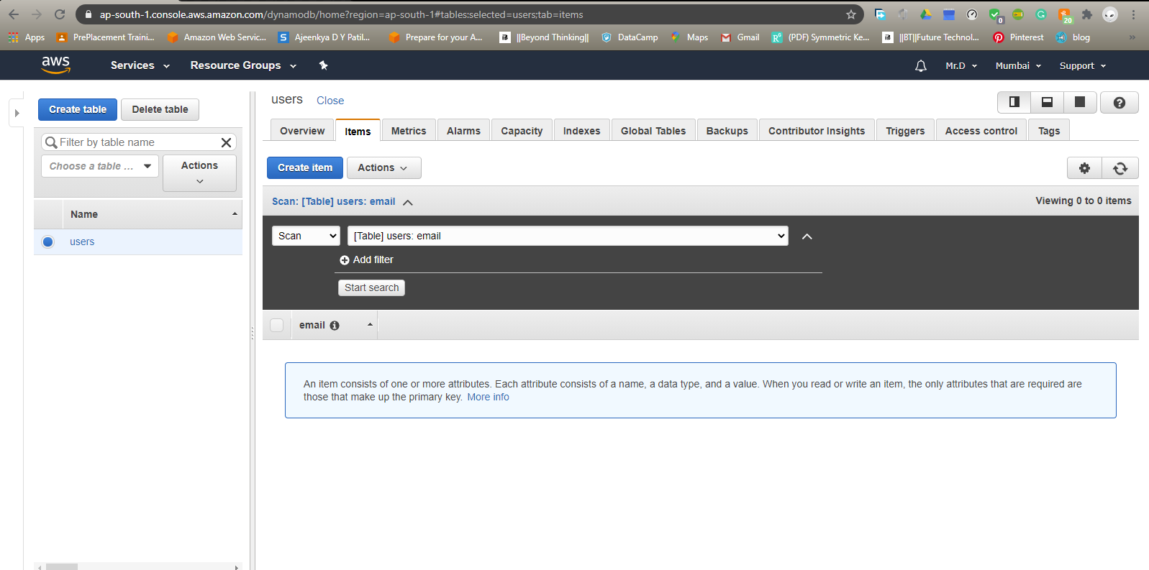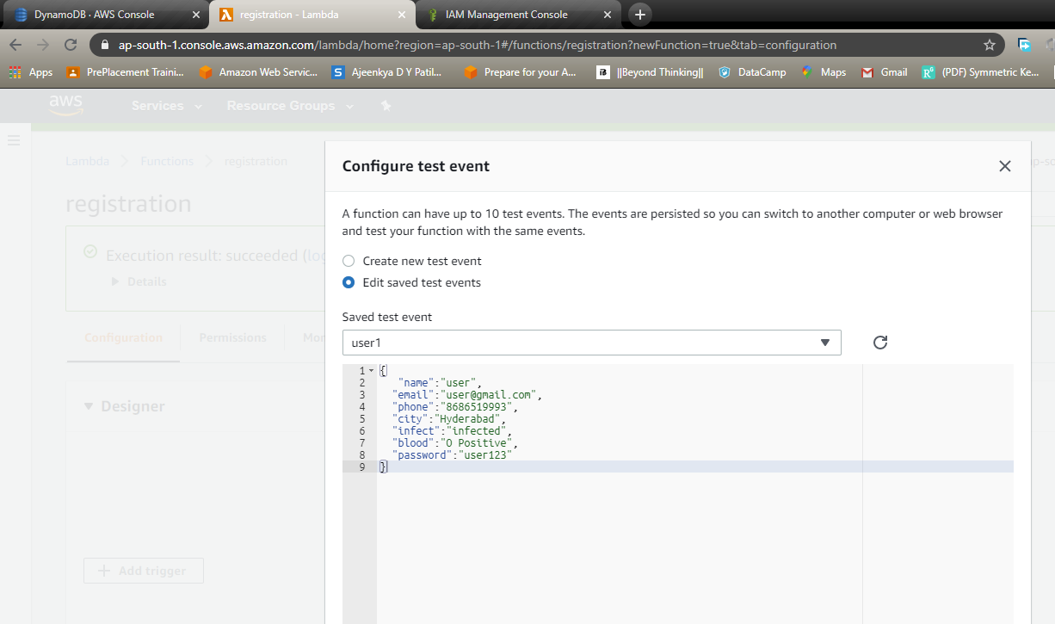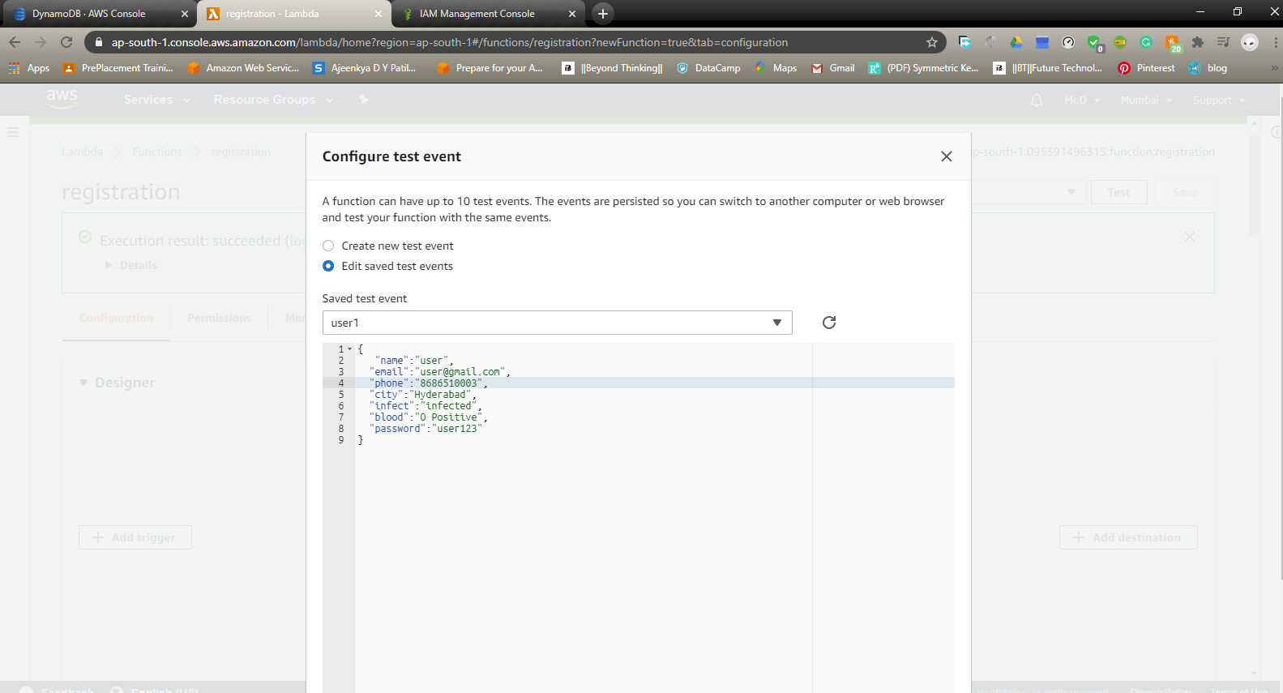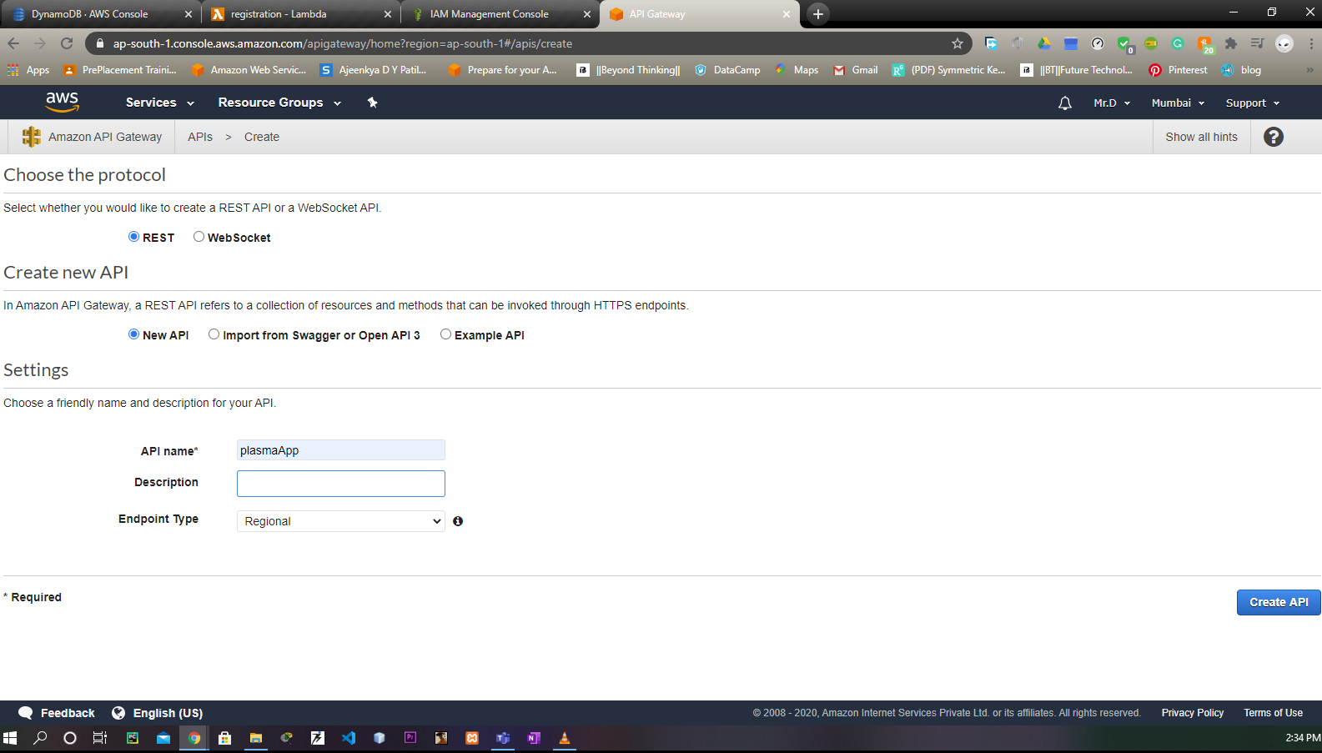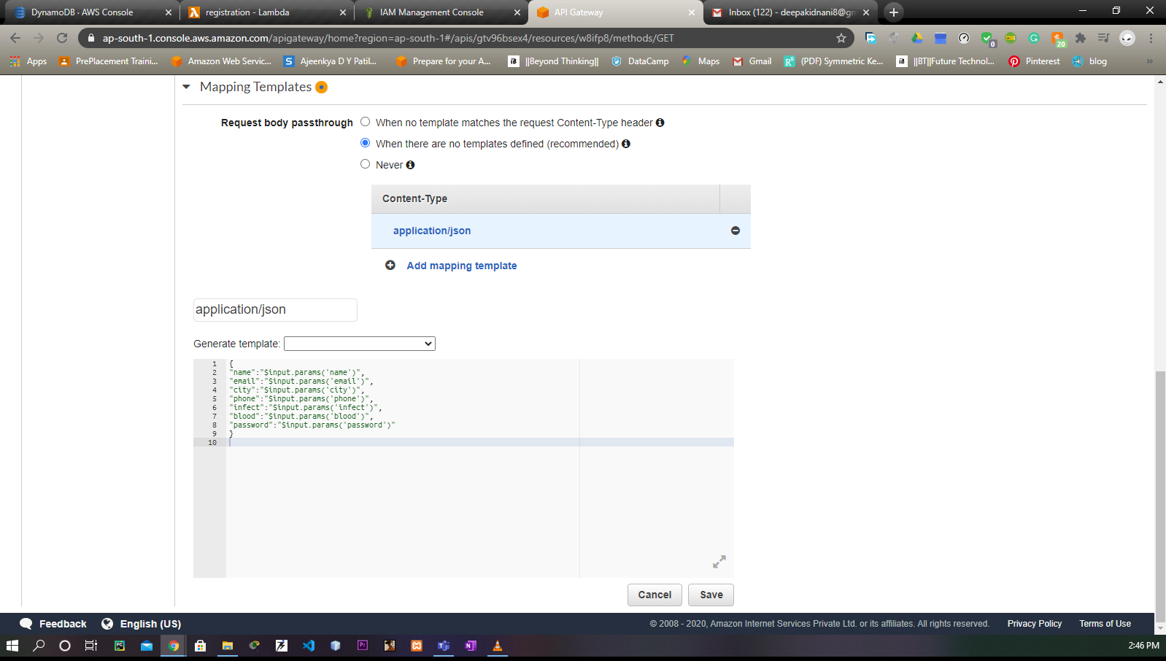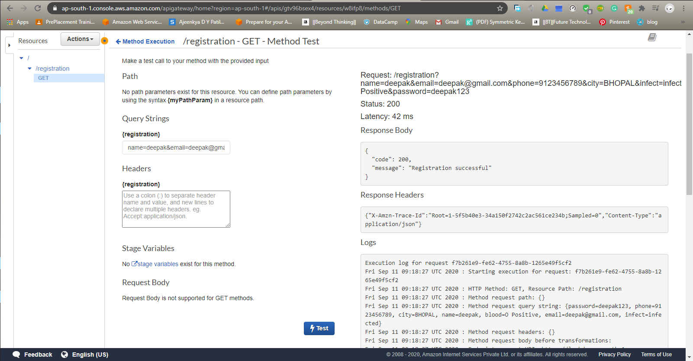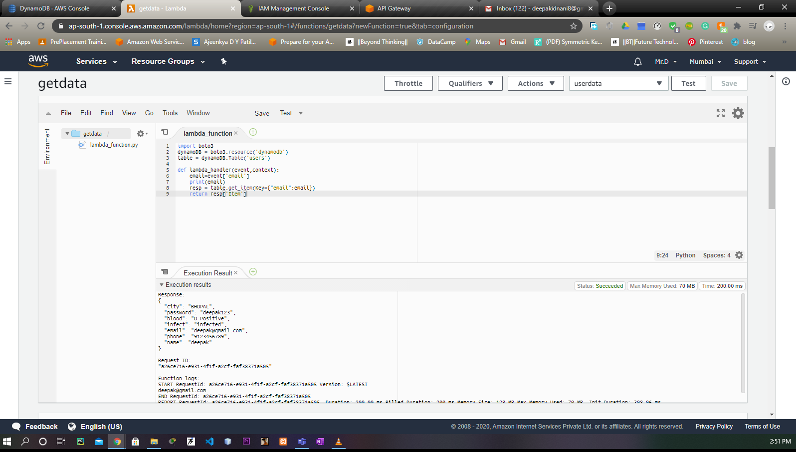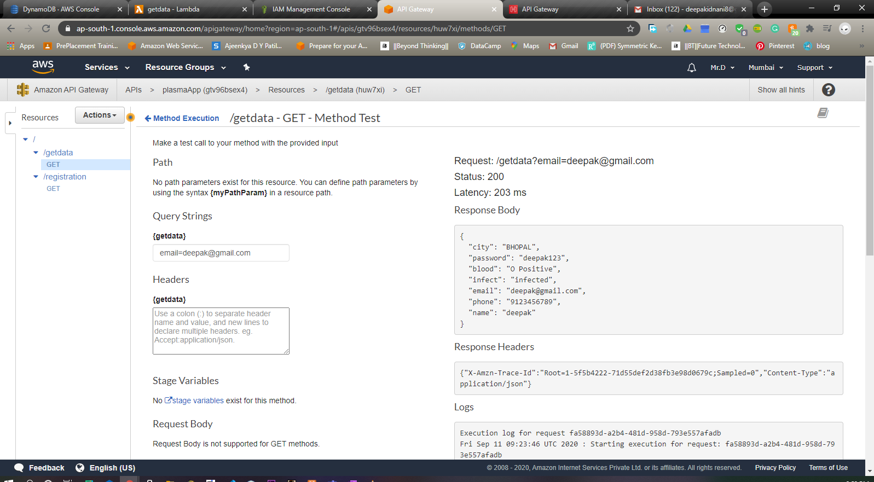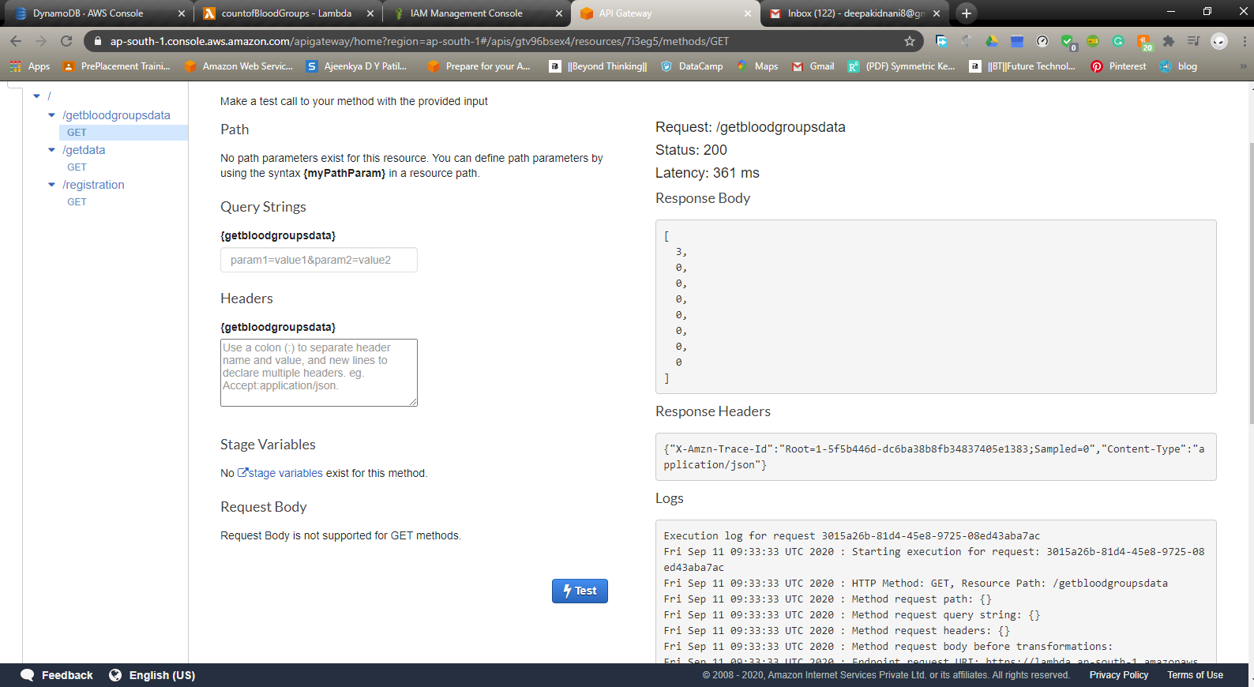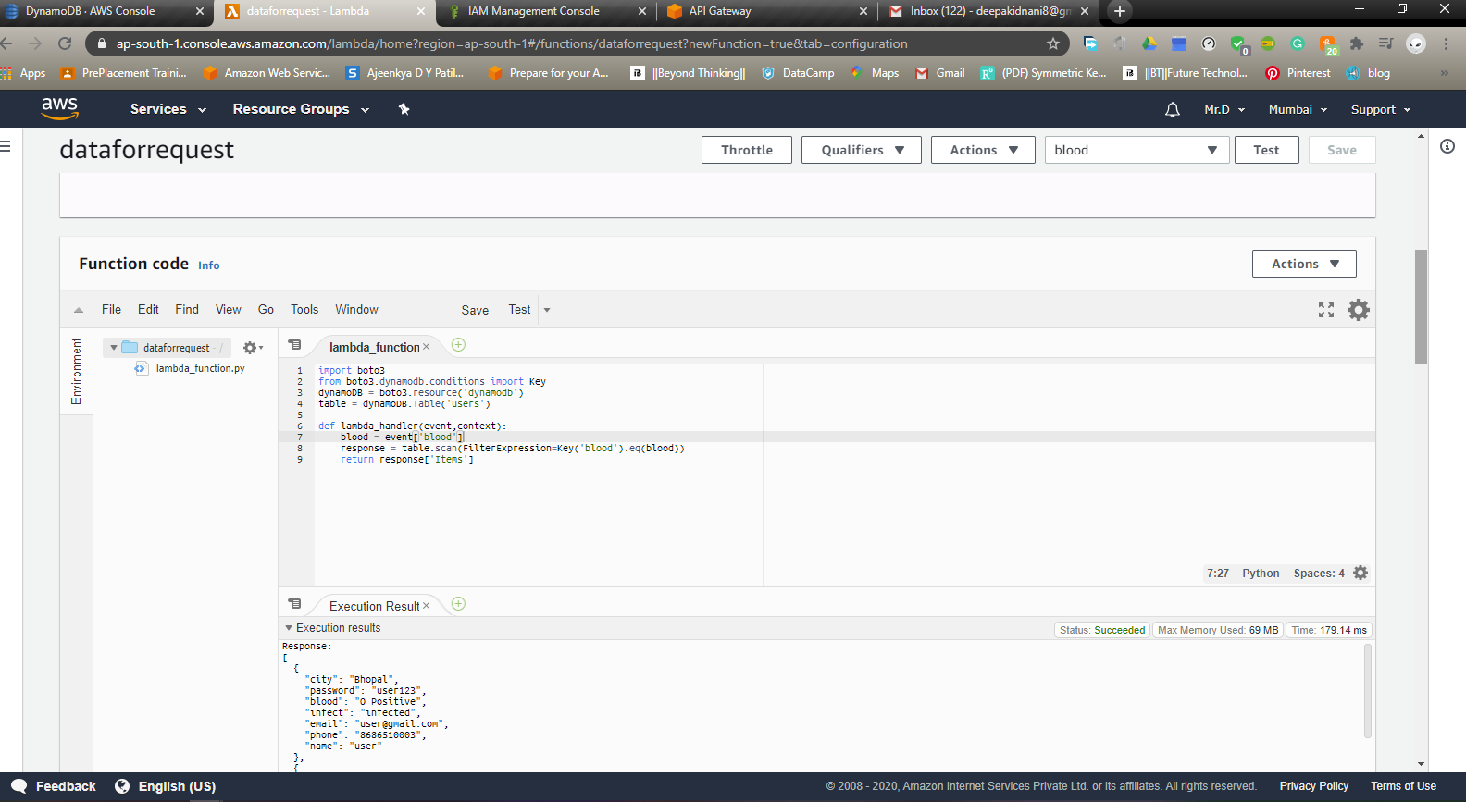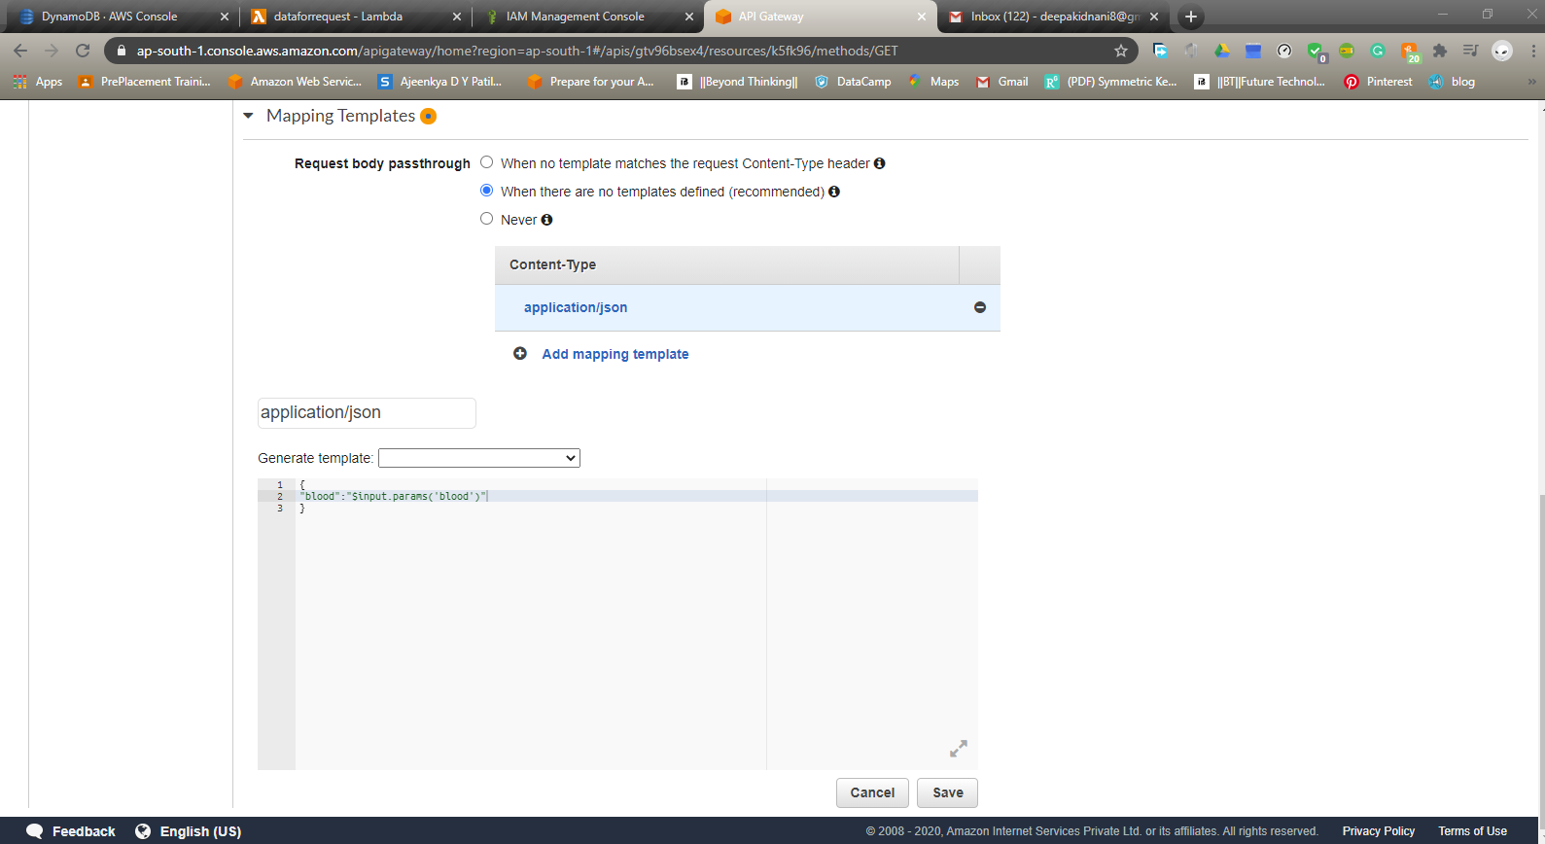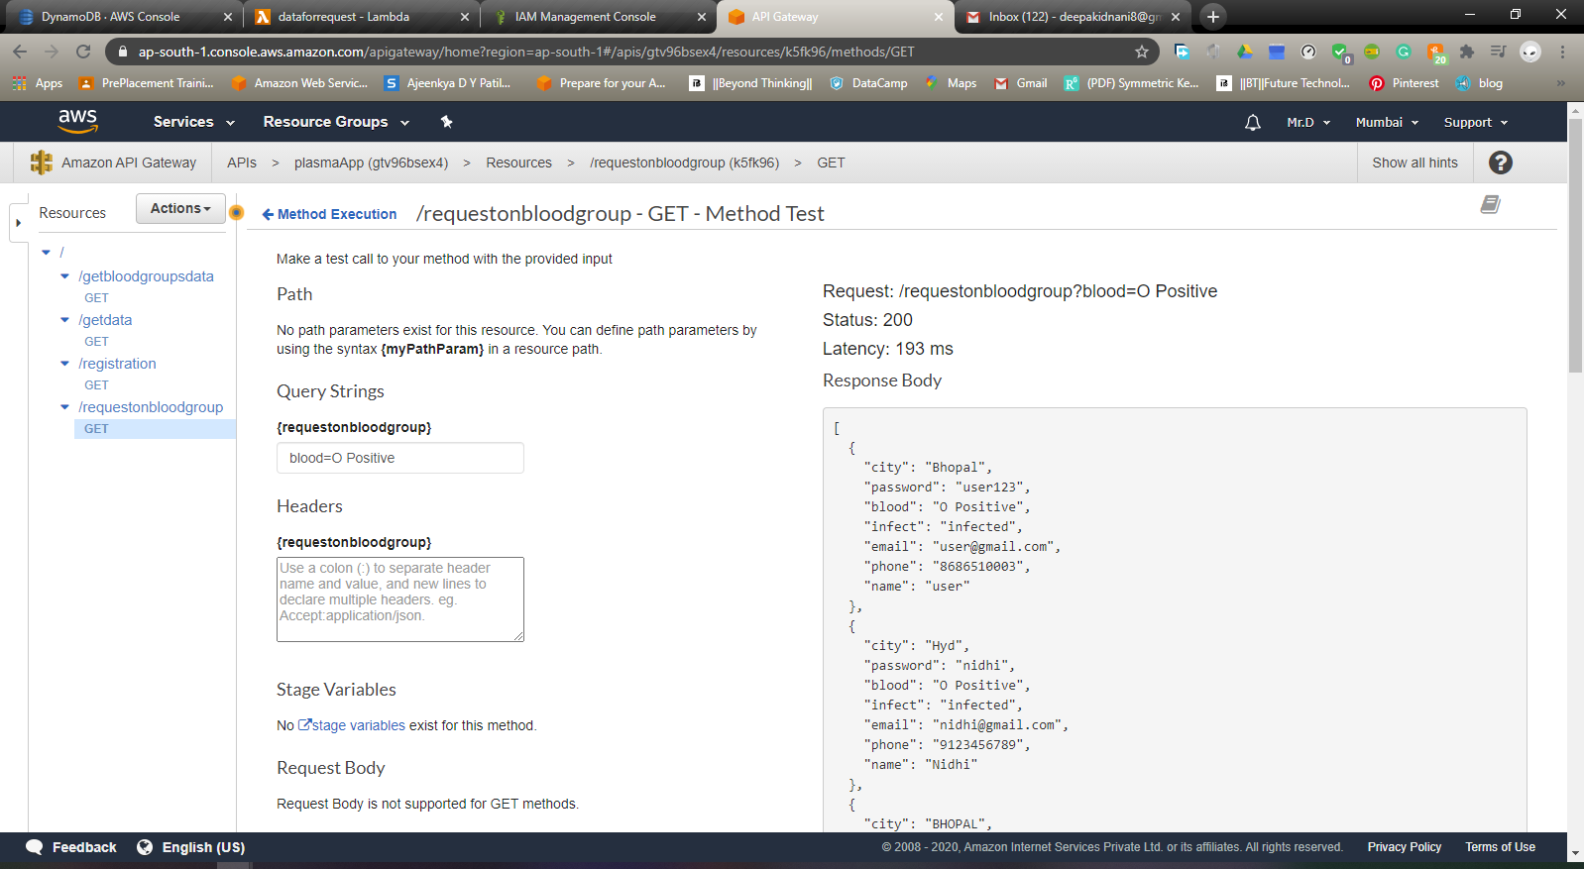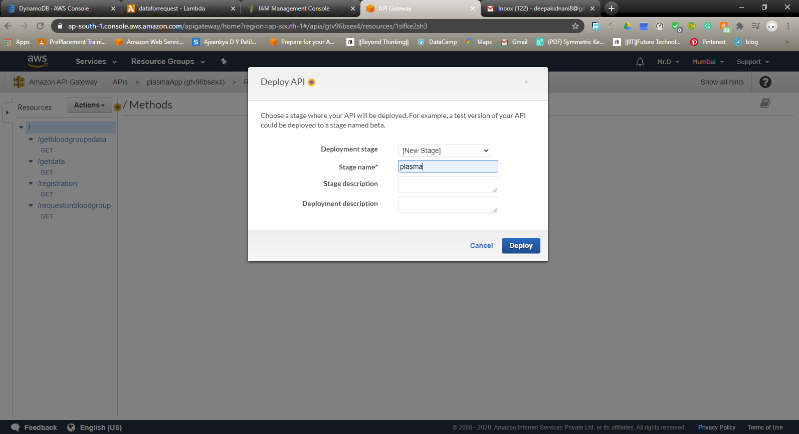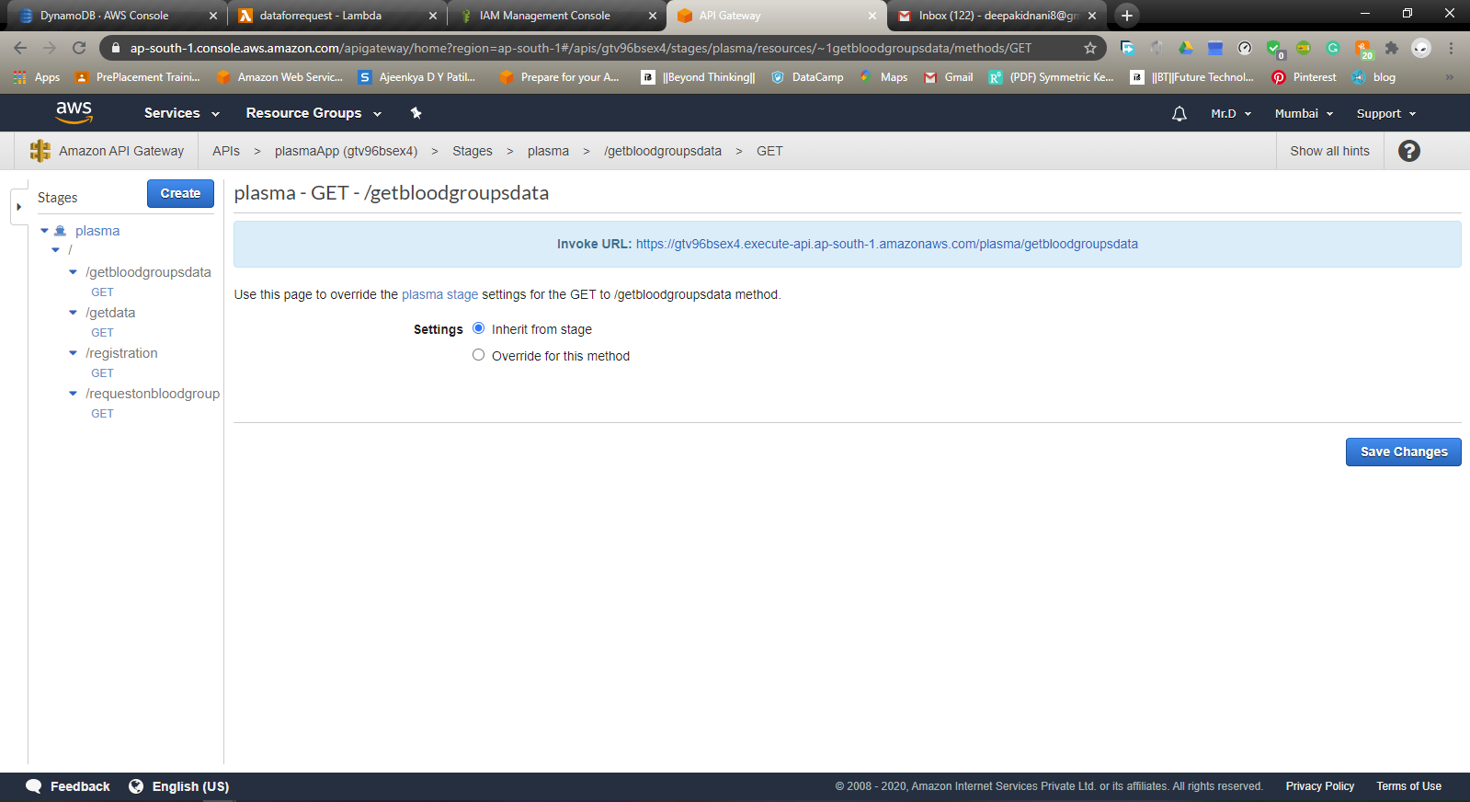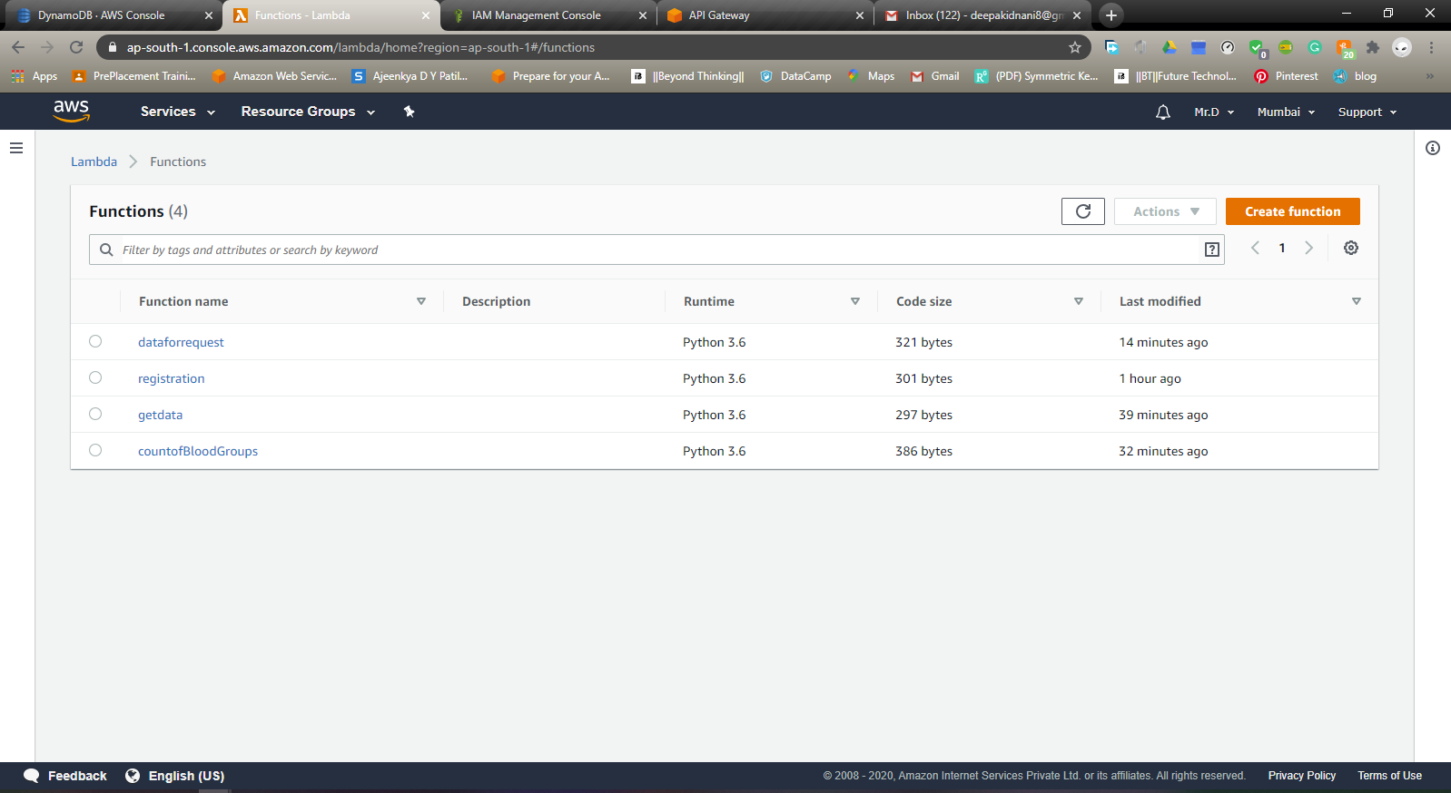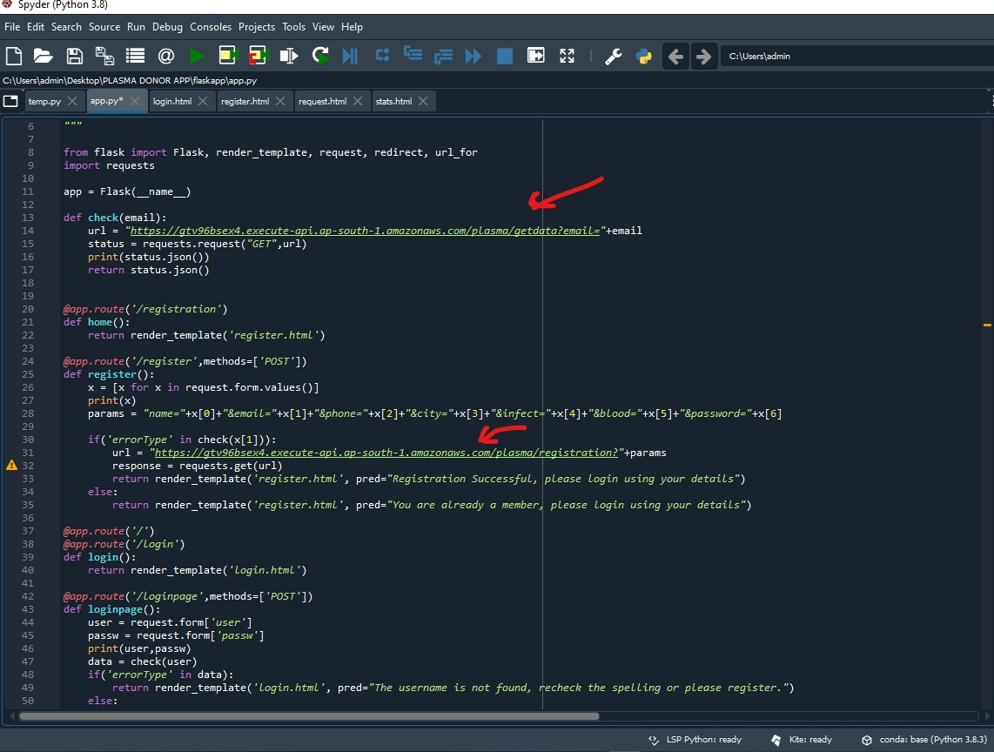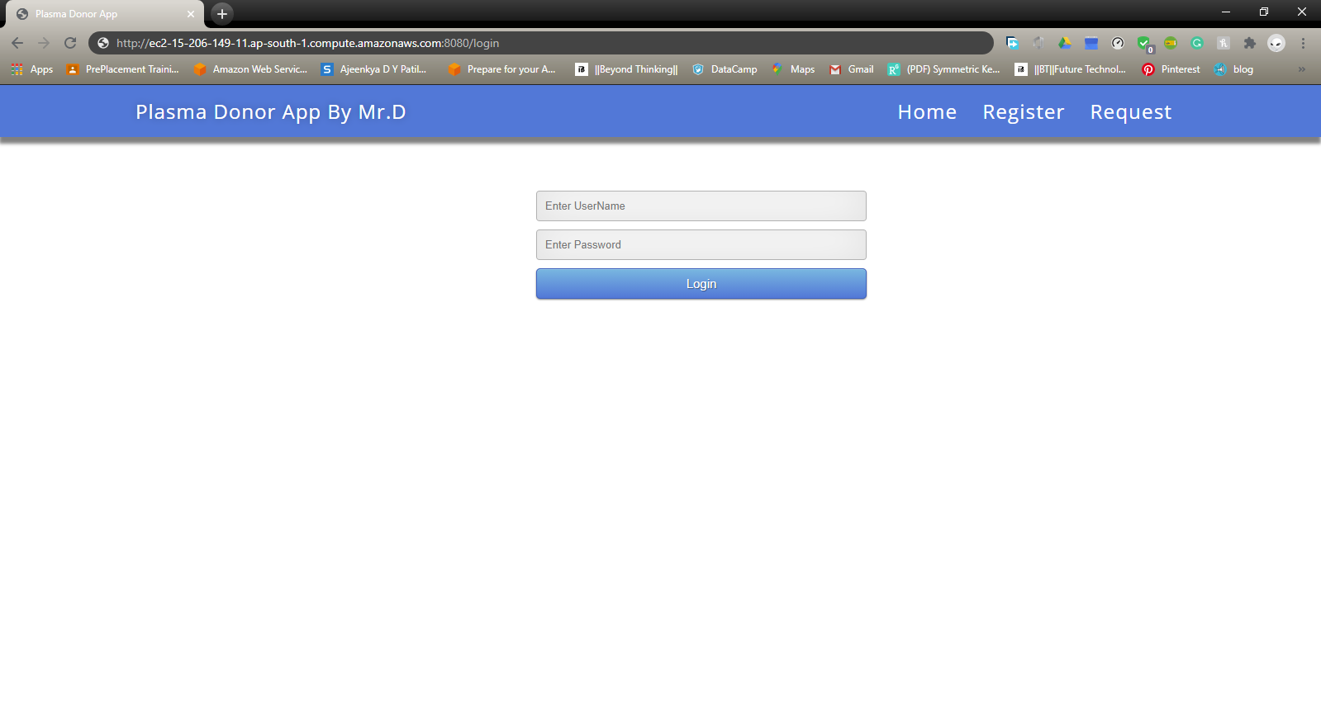 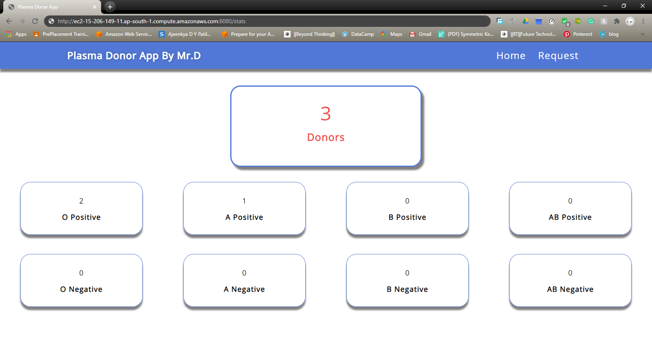 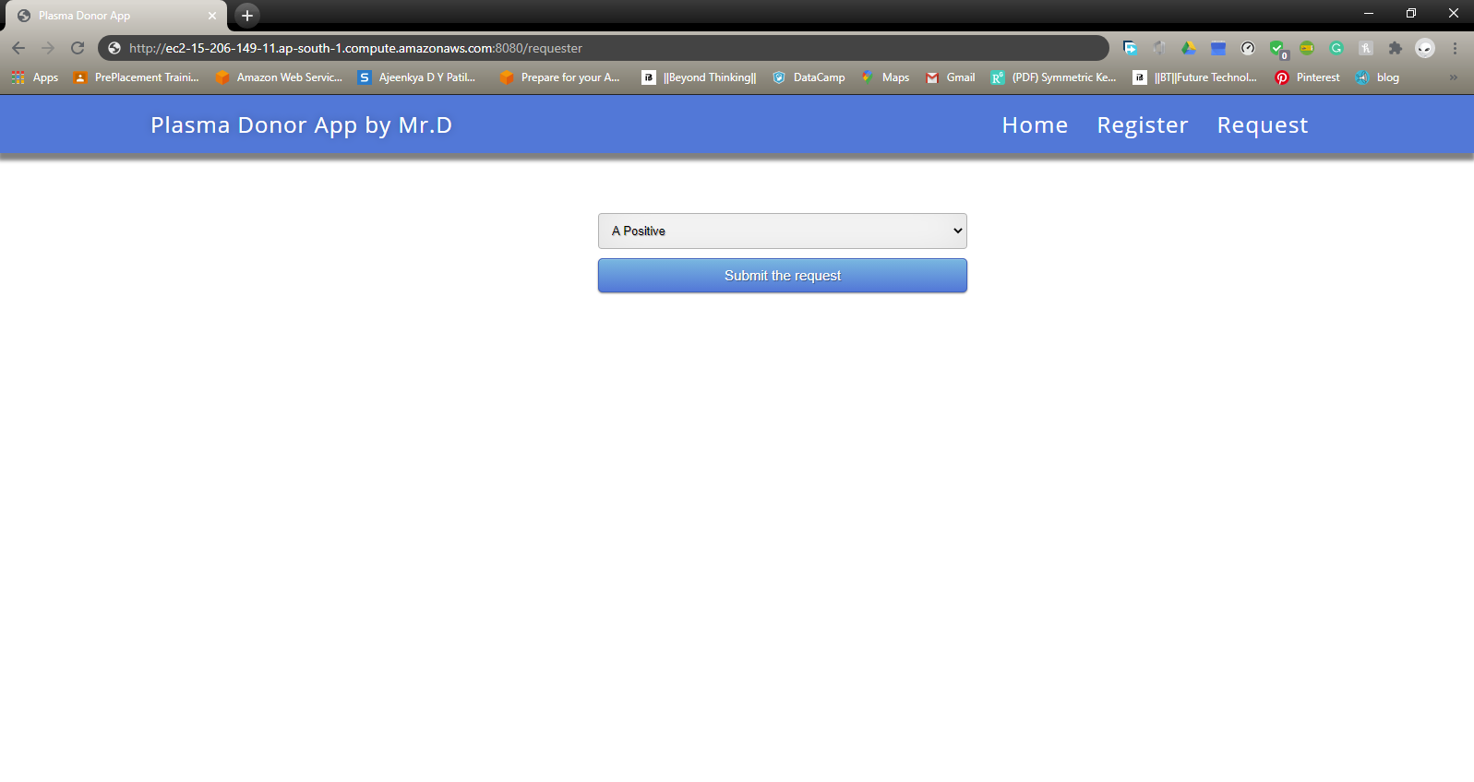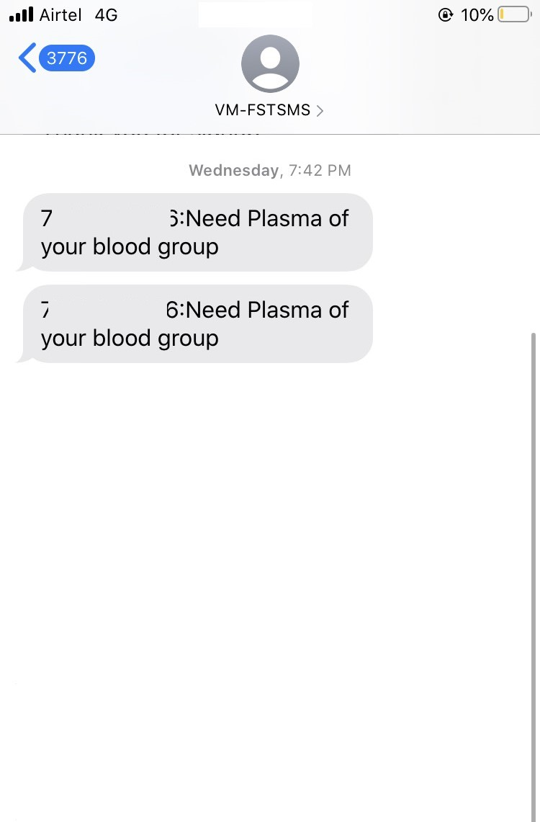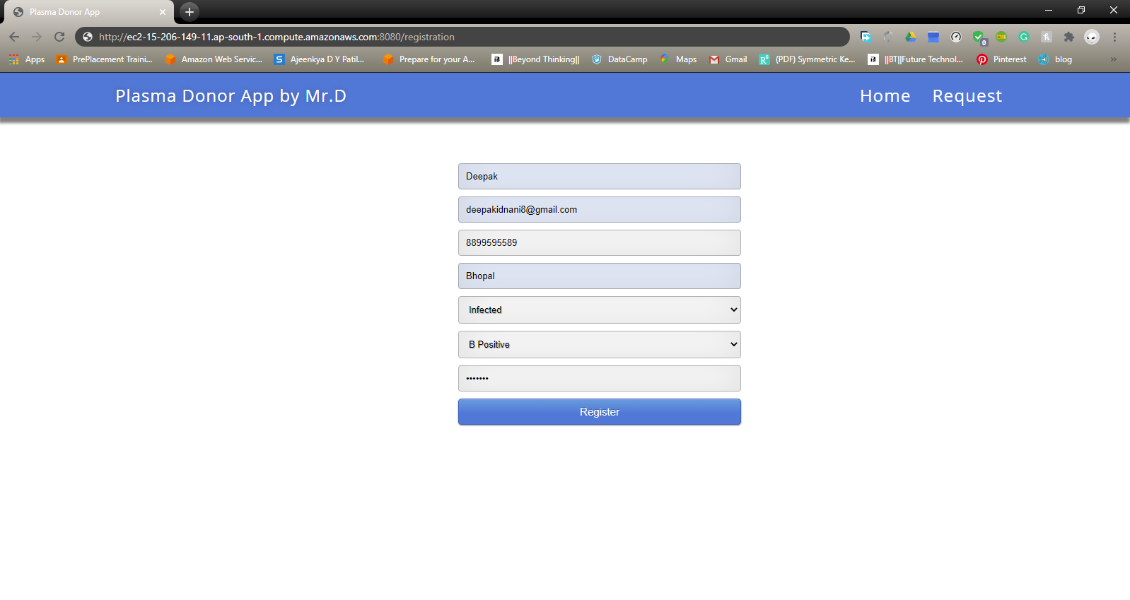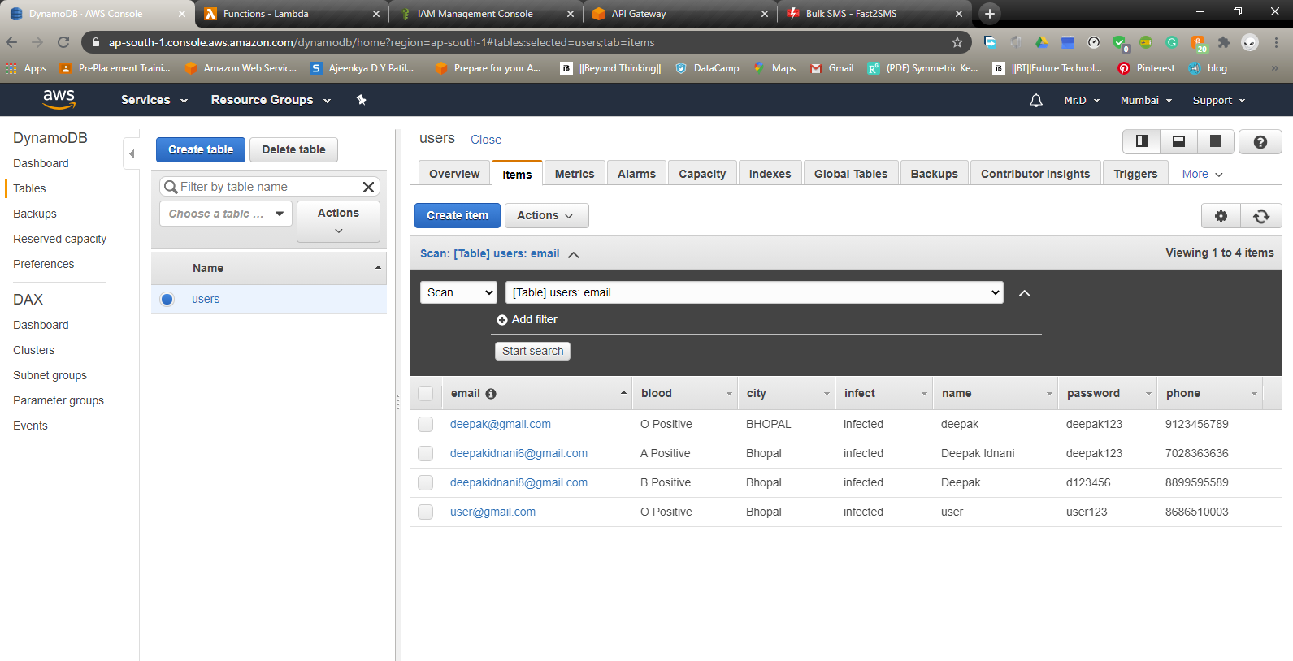

Application :

During the COVID 19 crisis, the requirement of plasma became high and the donor count being low. Saving the donor information and helping the need by notifying the current donors would be a helping hand. For developing this application we have used python flask framework

**AWS services which will be used for developing this project** :

* DynamoDB
* Lambda function
* IAM ( Identity and access management )
* API Gateway
* EC2

**Work flow:**

* The user interacts with the application.
* Register by giving the details as a donor.
* The database will have all the details and if a user posts a request then the concerned blood group donors will get notified about it.

**Architecture:**

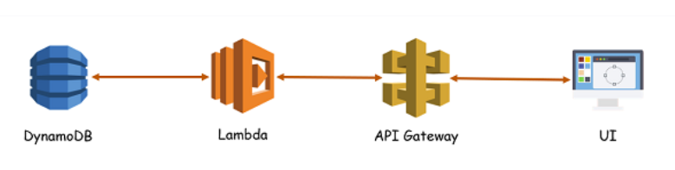

**DynamoDB**:

### Amazon DynamoDB is a fast and flexible NoSQL database service for all applications that need consistent, single-digit millisecond latency at any scale. It is a fully managed cloud database and supports both document and key-value store models.

### Lambda function:

### Lambda, a serverless compute platform that has changed the way that developers around the world build applications. It is a computing service that runs code in response to events and automatically manages the computing resources required by that code.

### API Gateway:

### Amazon API Gateway is an Amazon Web Services (AWS) service offering that allows a developer to connect non-AWS applications to AWS back-end resources, such as servers or code.

### 

### EC2:

### Amazon Elastic Compute Cloud (Amazon EC2) provides scalable computing capacity in the Amazon Web Services (AWS) cloud. Using Amazon EC2 eliminates your need to invest in hardware up front, so you can develop and deploy applications faster.

### Conclusion:

### With the help of this we have create an Serverless application which will be needful in this time of crisis

Future scope:

In this we will enhancing the GUI and also will be adding state based plasma donor service enable and also mention the cure days of the donor and many more things can be evolved to develop it more dynamic